A watchdog timer (WDT) is a hardware or software timer used in embedded systems and computer systems to detect and recover from system malfunctions.
A Watchdog Timer is like a supervisor for your system — especially used in embedded systems (e.g., microcontrollers like Arduino, STM32, PIC, etc.).
Its primary job is to detect when your system has crashed or become unresponsive and then restart it to restore normal operation.

Why is it Needed?
Computers or microcontrollers can:
- Hang due to software bugs (e.g., infinite loops, memory leaks),
- Crash from external noise (e.g., electrical interference),
- Or become unresponsive in unexpected edge cases.
If the system is not monitored, it will just stay stuck. A WDT makes sure this doesn't happen.

How It Works:
- The watchdog timer is started and continuously counts down.
- The system is expected to regularly reset (or "kick") the timer before it reaches zero.
- If the system fails to reset the timer (due to software crash, infinite loop, or hang), the timer expires.
- When it expires, it triggers a system reset or another corrective action to bring the system back to a known state.
- uring normal operation, the computer regularly restarts the watchdog timer to prevent it from elapsing, or timing out. If, due to a hardware fault or program error, the computer fails to restart the watchdog, the timer will elapse and generate a timeout signal. The timeout signal is used to initiate corrective actions. The corrective actions typically include placing the computer and associated hardware in a safe state and invoking a computer reboot.
Microcontrollers often include an integrated, on-chip watchdog. In other computers the watchdog may reside in a nearby chip that connects directly to the CPU, or it may be located on an external expansion card in the computer's chassis.

Why It’s Used:
- To automatically recover from software failures.
- Essential in systems that need high reliability or are deployed remotely (e.g., medical devices, automotive systems, satellites, etc.).
- Acts like a “fail-safe” mechanism.

- In real-time operating systems, a watchdog timer may be used to monitor a time-critical task to ensure it completes within its maximum allotted time and, if it fails to do so, to terminate the task and report the failure.

Types:
- Hardware Watchdog Timer – Built into microcontrollers or external ICs.
- Software Watchdog Timer – Implemented using timers in software (less reliable, since a frozen system might freeze the software watchdog too).

🧠 Example Scenario:
In a microcontroller:
- Your code has a loop that runs forever.
- Inside the loop, you reset the watchdog timer.
- If the loop freezes due to a bug, the watchdog timer isn’t reset.
- Timer expires → system resets → system tries to recover.

How Kicking Works in Different Contexts

1. In Embedded Hardware (Bare Metal Systems)
- Kicking is done by writing to a hardware register or executing a special instruction.
- Example: In PIC microcontrollers, the instruction CLRWDT (Clear Watchdog Timer) is used.
- Often, this must be done periodically from the main loop or interrupt routines to indicate the system is alive.

2. In Embedded Linux Systems
- The watchdog is controlled via a device driver and a device node, usually /dev/watchdog.
- A user-space program is responsible for kicking the watchdog:
  - Typically by writing to /dev/watchdog (e.g., writing a null byte).
  - Or by calling the ioctl() system call with the WDIOC_KEEPALIVE command.

Example:
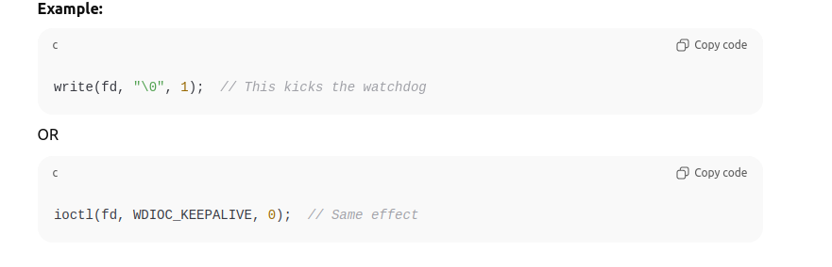

Windowed Watchdog Timers (WWDT)
Some watchdogs add an extra layer of reliability and strict timing through a windowed mechanism.

💡 What is a Windowed Watchdog?
- The watchdog timer can only be kicked during a specific time window.
- If you try to kick it too early or too late, it treats it as a fault.

⌛ Timing Example:
Let’s say:
- Total timeout = 1000 ms
- Kick window = between 400 ms and 900 ms
Time After Last Kick | Action | Effect
< 400 ms | Kick | Invalid – Too early (fault)
400–900 ms | Kick | Valid – Timer reset
> 900 ms | Kick | Invalid – Too late (timeout, reset)

